Using Video in iLearn with ARC
In this tutorial, you will learn how to record and upload videos onto iLearn.
Arc has features such as:
- Automatic closed captioning to comply with accessibility requirements.
- Commenting: students can ask questions or add their opinions.
- Tracking: you can keep track of students who watch the video


Step 1: From anywhere inside iLearn, click on the 'ARC' button on the left-hand side.

Step 2: Click on either the “Record” or “Add” button (upper right corner) to add a video into your arc library or to record a new video

- Record: You have the option of ‘Webcam’ or ‘Screencast’. The screencast option will need you to install a small program. This has worked well on both Windows and Mac computers.
- Add: Choose this to upload a video file you already have. The video should be on your computer, and you will pick it out.

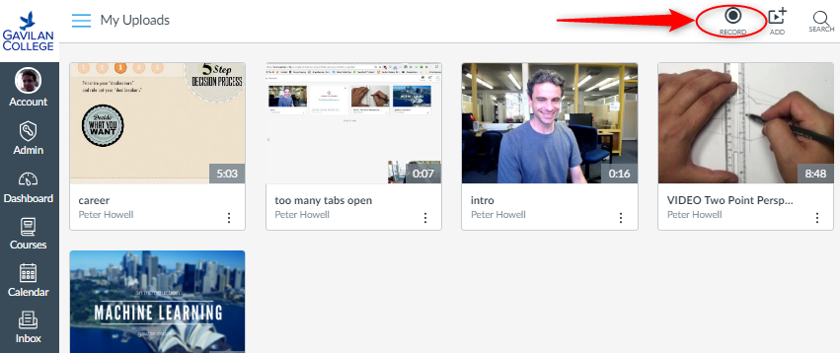

Placing Video in your Class
You can use this video in many different areas of your iLearn shell. Anyplace that lets you edit text, will let you place an Arc video and the optional comments system. You can put them in:
- Announcements
- Discussion forums
- Inside a webpage
- In an assignment or quiz description
Further, your students also have the same capability. This means that they too can record video and place it in a discussion forum or homework submission.
The process for doing this is similar in all cases. This is the text editor we see all over iLearn:
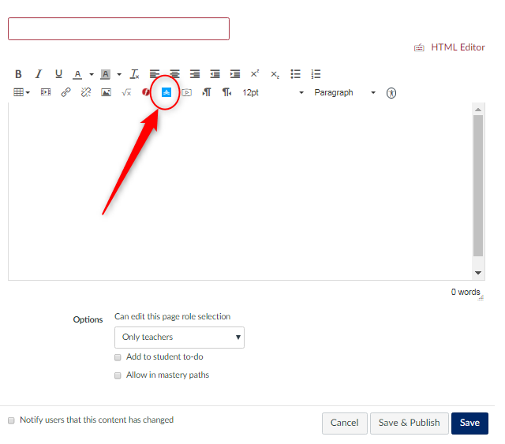
The circled blue button is how you’ll insert a video. Clicking it will let you pick out the video.
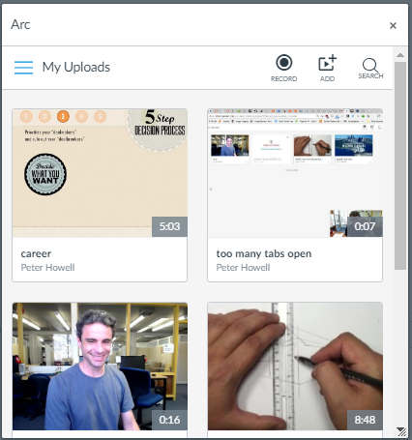
You can pick out any video you’ve recorded or uploaded.

Note that you can record and/or upload directly from this screen as well.

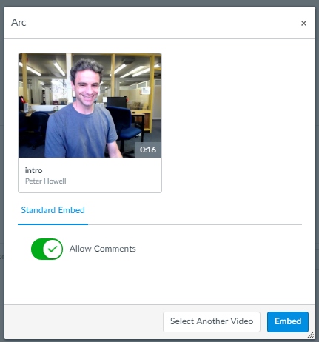
Once you’ve chosen a video, you have one more choice, which is whether to include the comments system, or leave it as a view-only video.

Click ‘Embed’ to finish the process. The video will be placed into the item you are editing, and you can now save and publish!

Requesting Captions
There is another step to request that closed captions be created for your video. This process is 90% accurate. You will need to return and correct any mistakes.
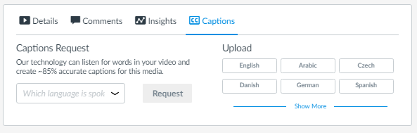
Simply choose a language and click ‘Request’.

